Project Report on

Match Making Website

Internet Tools and Technology Lab

By-

Anubhav Khanna

150911170

Roll No. 43

Vipul Johri

150911150

Roll No. 39

Shatabdi Chaudhuri

150911182

Roll No. 46

Shreekant Dashora

150911190

Roll No. 47

Completed under-

Ms. Chetana Pujari

(Faculty ICT Department)

INTRODUCTION

This project is a match making website which filters matches based on a general questionnaire about one’s likes and dislikes. It matches people It consists of a login and register page, a home page, a questionnaire page, profile page, a masthead page and a match page. It can be adapted to a fully functional website which can be popular among teenagers and youngsters.

FRONT END

HTML, CSS and Javascript is used to design the front end. Javascript is used to make the front end more user friendly and interactive. Bootstrap is used to make the front end more lively and realistic. Corner conditions for login and register have been met like necessary field cannot be left empty, emails should be entered in proper format, forgot password etc.

BACK END

The back end involves jQuery and MySQL for database along with PHP used through xammp software to make ensure that the transition between backend and frontend is smooth. 2 scripts on jQuery are used. One is a mobile jQuery which basically helps in creating responsiveness on the main page and other pages.

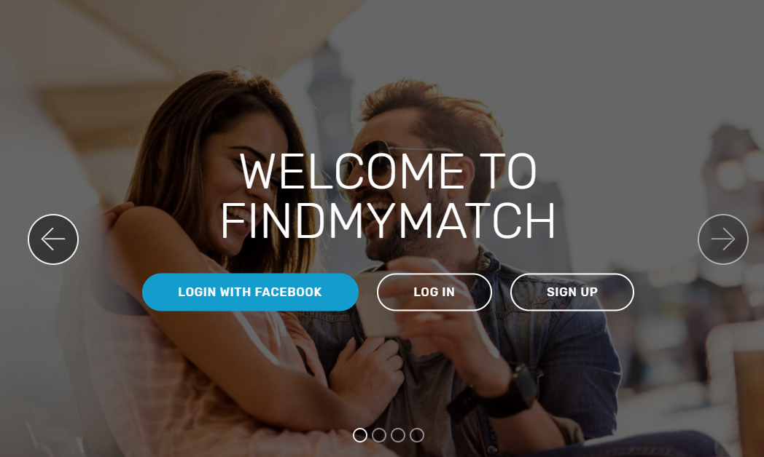

Main page allows you three options

* Log In using Facebook
* Log In
* Sign Up

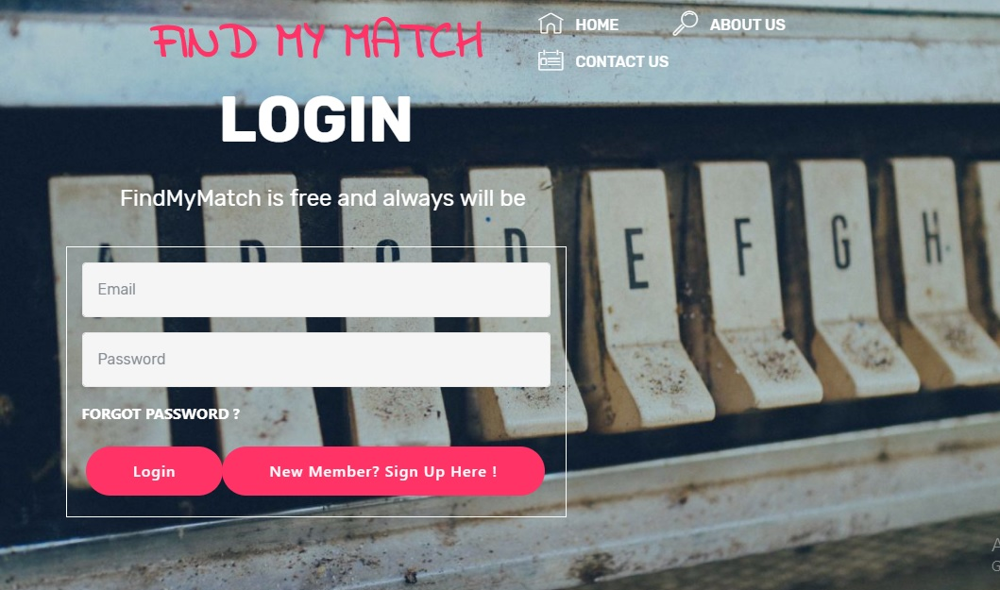

You can login using Email and password

If you’ve forgotten your password

You can reset it too.

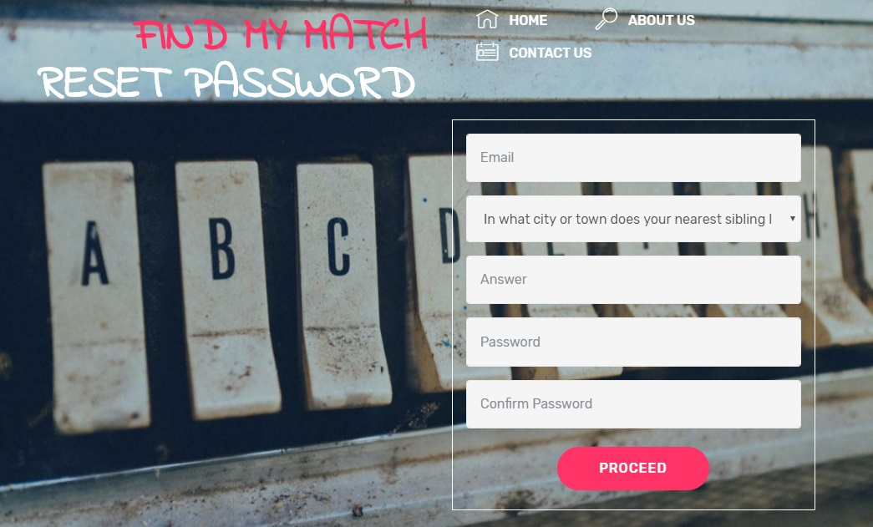

Reset Password using Email and Security question

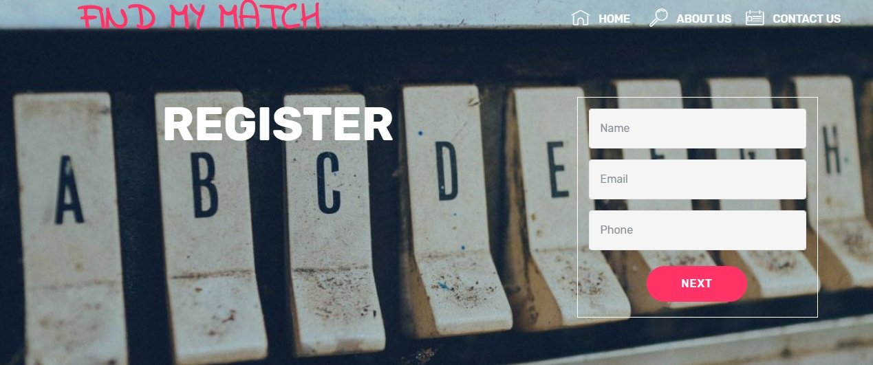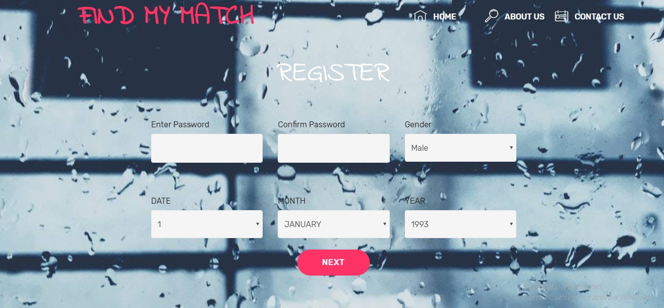

You can Register using these details

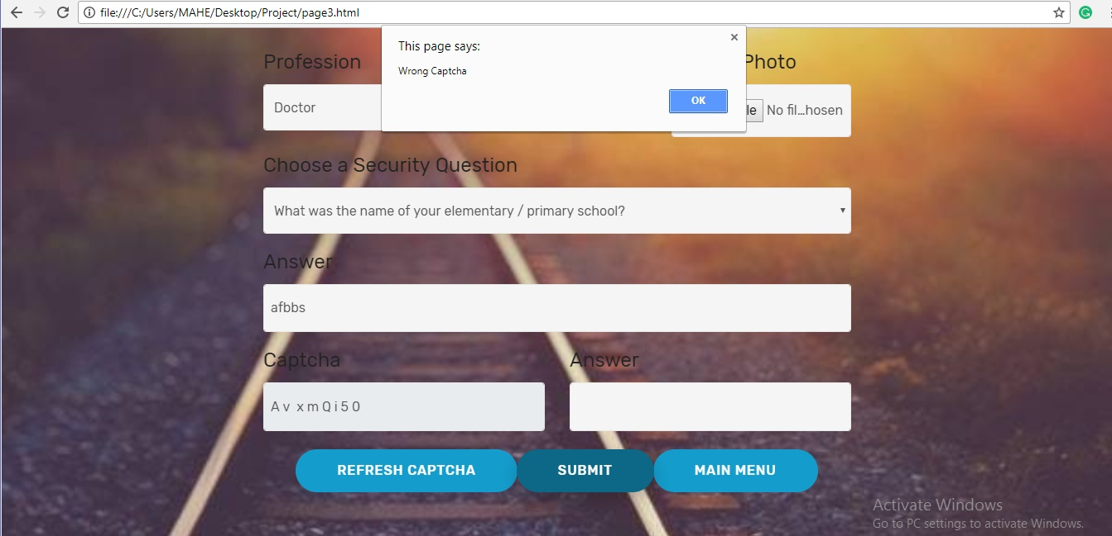

Captcha has to be correct for the form to submit

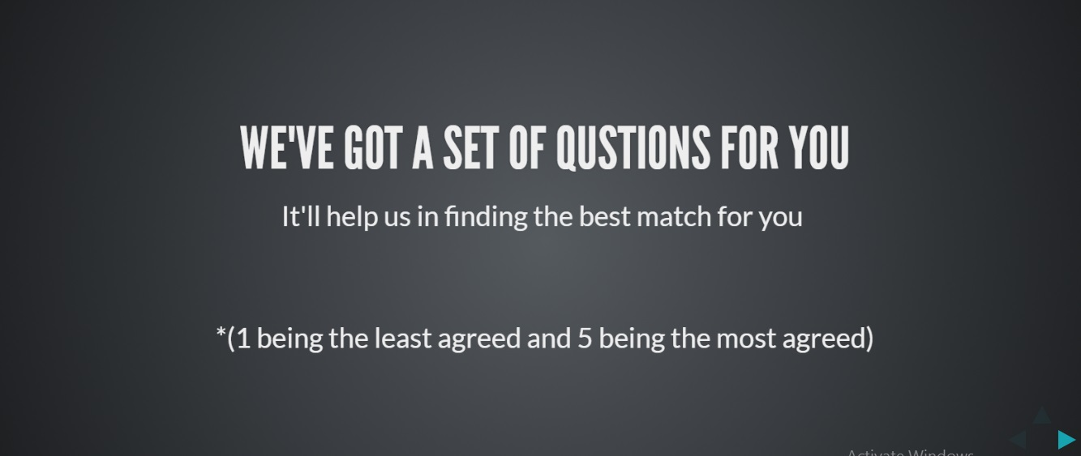

A set of questions have to be answered for the registration is complete.

My Home Page

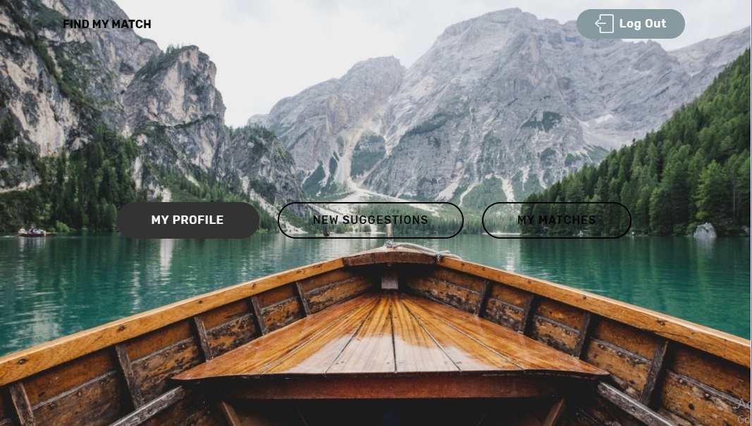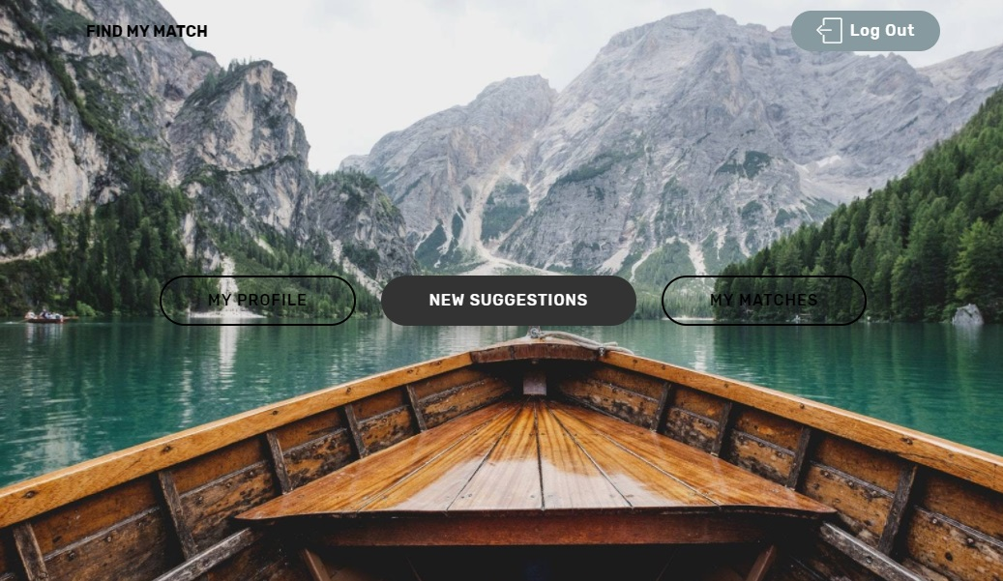

Here you get options to view your profile , viewing new matches and viewing already matched people.



Profile page :

This page shows all the details which are fetched through the backend and automatically entered in the form which is readonly .



Update profile :

You can change details in your profile here

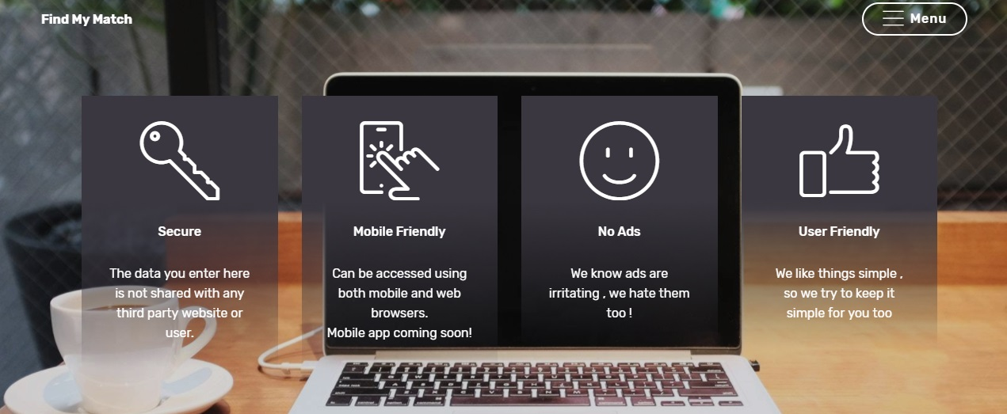

INFO:

All informati0on about website is provided here .

QUESTIONNAIRE

The questionnaire consists of 33 questions where the users mark their responses based on rating out of 5.

ALGORITHM

The match making algorithm works on the responses submitted by the users in the questionnaire.

FEASIBLE ADDITIONS

* HOSTING THE WEBSITE

The website can be hosted and be made available to the public after testing. Target audience would be mostly teenagers and youngsters.

* FACEBOOK LOGIN

The website can be added with login with Facebook feature for faster and easier registration and login.